Policy Title:  Residential New Builds Policy | Reviewed By: | Jurisdiction:  Town of Southey | Effective Date:
Origin/Authority: | Adopted By: | Policy Number: | Pages:

Residential New Builds Policy:
Purpose:
This policy provides and introduction to a tax incentive for new residential builds in the Town of Southey.

Incentives as follows:
Year one pays 0% Municipal Tax
Year two pays 50% Municipal Tax
Year three pays 75% Municipal Tax
Year four pays 100% Municipal Tax

Passed at _______________, 20___ Meeting.

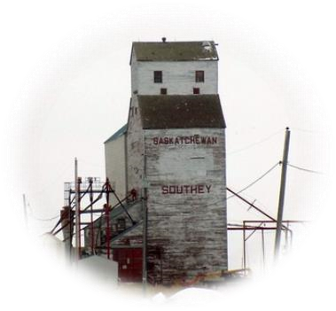
Mayor: _________________ Chief Administrative Officer: __________________

